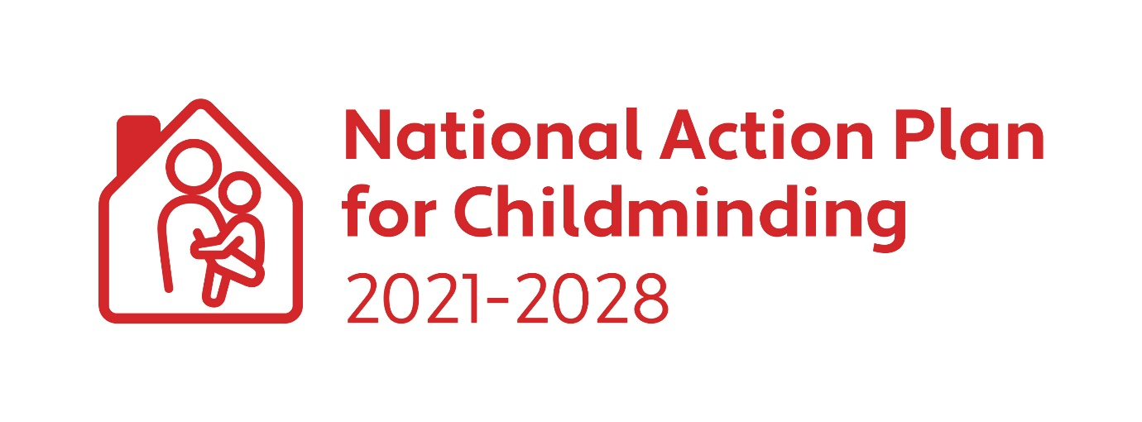CHILDMINDING DEVELOPMENT GRANT 2024
Application Form

Closing Date for Applications: Friday 7 June 2024

Applicant Details:

Name of Applicant:
Childminding Business Name: (Optional)
Address of Applicant:

Mobile Telephone:
E-mail:
I am a Tusla Registered Childminder: ☐

I am not required to register with Tusla: ☐

I am planning to be a Childminder in 2024: ☐

I declare that I do not have any previous convictions for any offence involving violence or harm to children/adults: ☐ Yes

Evidence of Childminding Insurance submitted: ☐ Yes
Or
New/potential childminder ☐ Yes
New/potential childminders must start childminding by the return date of the expenditure form Friday 18 October 2024 and must submit a copy of childminding insurance at this time.
Evidence of completion of Tusla Children First E-Learning Programme submitted: ☐ Yes
Current Tax Clearance Certificate submitted: ☐ Yes

By ticking this box, I agree to the retention of my contact details by the DCEDIY and my local City & County Childcare Committee for the purposes of sharing updates and engaging in consultation, relating to the implementation of the National Action Plan for Childminding 2021-2028: ☐
You can withdraw your consent at any time by email to your local CCC.

Please give a brief description of what you intend to spend the grant on (Max 200 words):

State the total amount of grant you are applying for.

€

Please refer to Childminding Development Grant (CMDG) Applicant Guidelines for details of eligible and ineligible spends. Please contact your local CCC to discuss your intended purchases to ensure that they will be eligible under the grant conditions.

The grant will be paid into your bank account, please input your bank details here:
(Please use block capitals)

Bank Details

Account Name:
Payee Address:
IBAN:
BIC:
Bank Name:
Bank Address:

Applicant Declaration:
I understand and agree to the following terms and conditions:
- To comply with all the terms and conditions set out in the CMDG 2024 guidelines.
- Where required, I am compliant with the Child Care Act 1991(Early Years Services) Regulations 2016 and/or Child Care Act 1991 (Early Years Services) (Registration of School Age Services) Regulations 2018; Fire Services Act 1981 & 2003 and the Building Control Acts 1990 and 2007.
- That I will receive correspondence from my local CCC with the grant agreement plus any conditions of funding.
- If my application for funding is successful, but the Childminding Development Grant national budget is oversubscribed, I may receive a lesser amount than I applied for.
- That if I am unsuccessful, I will receive correspondence from my CCC setting out why my application has been refused.
- Upon receipt of my signed grant agreement the CCC will issue 75% of the total grant approved to me according to the timeline set out in the approval letter.
- I must submit my CMDG Expenditure Report and receipts and any other required documents to my local CCC any time before Friday 18 October 2024. Failure to submit the CMDG Expenditure report and receipts will result in the CCC implementing the unspent/ineligible funding guidelines.
- I understand that the grant money is not tax free.
- I may receive a compliance visit. I will receive notice of such a visit, and I agree to provide reasonable assistance during such visit.
- As an existing childminder, I agree to continue to provide a childminding service for at least 12 months following receipt of the grant.
- As a potential childminder, I must begin childminding by the final date for submission of the expenditure report, Friday 18 October 2024.
- Any unspent funds from the first 75% awarded must be returned to the City/County Childcare Committee.
- All or part of this grant may need to be returned if the expenditure has been deemed ineligible by the City/County Childcare Committee.
- Any failure of technology or disruption to internet services affecting submission of the application will be at my own risk and neither the CCCs nor the DCEDIY accepts any liability if the full application fails to be submitted with supporting documentation or is rejected as a late submission.
- I hereby give authorisation to my local City/County Childcare Committee to make an online payment transfer to my bank account
- The signed and returned grant agreement represent the contract between myself and the local City/County Childcare Committee.
- I agree to indemnify CCC, Pobal and the Exchequer from and against all actions, proceedings and costs, claims, demands and liabilities howsoever, arising from all and every action in connection with the approved project.
- I declare that the information provided is true and complete.

Repayment of Grant Aid to City/County Childcare Committee
The CCC can cancel the grant, withhold any grant monies unpaid to date, and look for repayment of any monies that have already been paid to the successful applicant, if the successful applicant fails to comply with the terms of this agreement.

Disclosure under the Freedom of Information
Under the Freedom of Information Act 2014, the information in this document and its attachments may be released on request to third parties.
If you believe that any of the information in this document is sensitive and should not be disclosed to a third party, you must identify the sensitive information and provide the reason(s) for its sensitivity at the time of the application.
You will be consulted about the sensitive information before any decision is made to release the information to a third party. If you do not identify any of the information supplied in this document and supporting documentation as being sensitive you are acknowledging that any, or all of the information supplied, may be released in response to a Freedom of Information request.
Please outline the sensitive information and the reason(s) for the sensitivity below and submit with your application:

General Data Protection Regulations:
All records and data will be processed in compliance with GDPR. Please see the DCEDIY Privacy Notice for further information.

Early Learning and Care Services and School Age Childcare Services must ensure that they are fully aware and comply with their obligations and responsibilities in relation to processing personal data within their service(s). Please refer to the Data Protection Commission for additional information in relation obligations in relation to GDPR. Here is a link to their website: Data Protection Commission Guidance

The DCEDIY is the Data Controller for personal data processed for the CMDG. The DCEDIY privacy notice can be accessed at: https://www.gov.ie/en/help/privacy-policy/

City & County Childcare Committees/Pobal as Data Processors will process applications under the instructions of the DCEDIY. Your information will be processed in the following ways:
- Contact details and bank account information from the application form will be used for the payment process for this grant.
- The information contained in your application form may be used for research purposes by the DCEDIY or Pobal in relation to the impact of this funding on the early years’ sector.

As part of the administration and management of this grant the City/County Childcare Committee/DCEDIY and/or Pobal may share the information in this application form with other Departments, Statutory Bodies, or their agents.

PLEASE NOTE:
Late applications will not be accepted. Only complete application forms with the relevant supporting documentation will be processed. All application forms must be scanned or posted; photographs of application forms will not be accepted.

Signature of Applicant

By signing below, I confirm I have read, understand, and accept the terms and conditions outlined above in this Application & Declaration.

Applicants Signature: ________________________________

Date: ________________

Please send your completed application form to your local City/County Childcare Committee by 5.00 pm on Friday 7 June 2024. Contact details for your CCC can be found at myccc.ie

Checklist for Applicant

Please tick when completed | Applicant  Please tick
CMDG application form. Should be signed by applicant
Evidence of appropriate childminding schedule of insurance (Insurance must be in date at time of application).
New/potential childminders must start childminding by the return date of the expenditure form (18 October 2024) and must submit a copy of insurance at this time.
Copy of Tusla Children First E-Learning Programme Certificate (dated in the last 3 years)
Current Tax Clearance Certificate in applicants name
Tick the consent for the retention of contact details for the purposes of information sharing in relation to NAPC 2021-28
Please Note: This is optional
Bank details are complete and legible
Signed applicant declaration
Application form grant application is in line with the eligible spend as per the guidelines

